Quiz

1. What is an Event Loop:

 a programming construct or design pattern that waits for and dispatches events or messages in a program

1. How do you add an element at the begining of an array? How do you add one at the end? Hint[ 2 ways ]

Push(): add the element to the end of the array

Unshift(): add to the beginin

Question 2:

1. Output =3

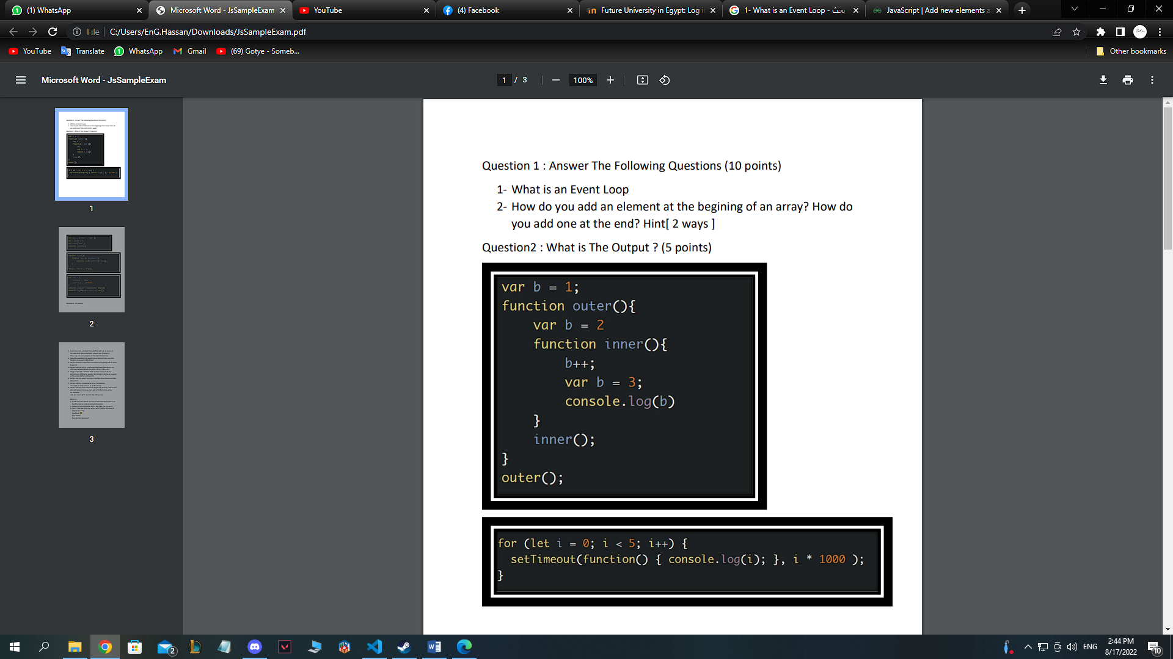\

2)01234

3)baz

4) 1hellotrue

5)true

Carname:bmw

carPrice:1000000

Question 3:

1. Create Function sumObjectValues() that will sum all values of the fields that contain numbers .

const obj = {

    one: 5,

    two: 15,

    three: 45,

  };

  const values = Object.values(obj);

  const sum = values.reduce((accumulator, value) => {

    return accumulator + value;

  }, 0);

  console.log(sum);

1. Show the execution of 3 asynchronous block of code, one after the other in sequence

3)Get the maximum value from a numbers array along with its index

Function indexofmaximum(a){

If(a.lenght===0){

Return -1;}

Var max=a[0];

Var maxindex=0;

For(var i=1;i<a.lenght:i++){

If(arr[i]>max){

Maxindex=I;

Max=a[i];}}return maxindex;}

4) Write a function which accepts two valid dates and returns the difference between them as number of days

Fuction getNumberofdays(start,end){

Const date1= new date (start);

Const date2= new date (end);

Const oneday=1000\*60\*60\*24;

Const diffintime =date2.getTime - date.getTime();

Const diffinDays=Math.round(diffintTime/oneDay);

Return diffinDays;

Document.write(getNumberofdays(“15/8/2022”,”17/8/2022”));

5) Design a Calulator interface for 2 number inputs which can perform sum, difference, product and dividend whenever invoked on the same interface.

let x=parseInt(prompt('Enter the number 1 = '))

let y=parseInt(prompt('Enter the Number 2 = '))

let options=prompt('Enter the option')

switch(options){

case'+':

document.write(x+y)

break;

case'-':

document.write(x-y)

break;

case'\*':

document.write(x\*y)

break;

case'/':

document.write(x/y)

break;

6) Write a function which can return multiple values from a function

function name(){

let fname=’hassan’,

lname=’zakaria’

return[fnmae ,lname]}

}

7) Write a function to reverse an array. For Example : reverse([1, 2, 3, 4]) ➞ [4, 3, 2, 1] (10 points)

let a=[1,2,4,5];

Let reverseA=[a]reverse();

Document.write(a);

Document.write(reverseA);

8) Write a function that converts an object into an array, where each element represents a key-value pair in the form of an array.

const x={firstName:’jony’,lastName:’jhon’};

Const propertyName=Object.keys(person);

Document.write(propertyName);

Const entries =object.entries(x);

Document.write(entries);

Bouns :

1) const convertTime12to24 = time12h => {

   const [time, modifier] = time12h.split(" ");

   let [hours, minutes] = time.split(":");

   if (hours === "12") {

     hours = "00";

   }

   if (modifier === "PM") {

     hours = parseInt(hours, 10) + 12;

   }

   return `${hours}:${minutes}`;

 };

 var convertedTime = convertTime12to24("04:00 PM");

 console.log(convertedTime);

2)Function add(x){

Return function(y){

return x+y;

}

}

Var a=add(2)(3);

Console.log(a)

3) var arr = [{ name: 'JOHN' },

  {  name: 'JENNIE'},

  {  name: 'JENNAH' }];

function userExists(name) {

  return arr.some(function(x) {

    return x.name === name;

  });

}

console.log(userExists('JOHN'));

console.log(userExists('JUMBO'));